* Page designs for each page showing the layout, design metaphors and technical details of the media used on the page. Specify which elements are static and which are dynamic

Page layout:

Product.html page: When you click the navigational link of “books”, it will enter this page. The following figure is the page layout.

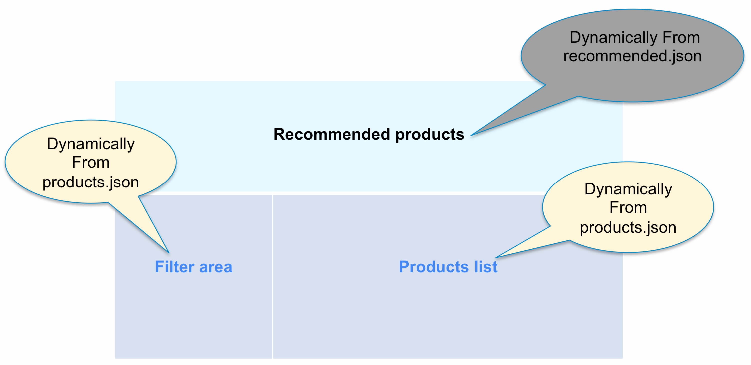

Description:

* Top: Show recommended products, and the information is dynamically come from recommended.json which is a online file.
* Left: It is a filter area, and it’s html code is dynamically populated.
* Right: Right is the main area, it is show the products list, and it is dynamically come from products.json which is a online file.

productDetail.html: In product.html page, if you want to know more information of a product , you can click it’s link, and then it will transfor the id to this page. In this page, if it get the ID of a product ,it will use ajax to get the product information, then show in this page. The following figure is the page layout.

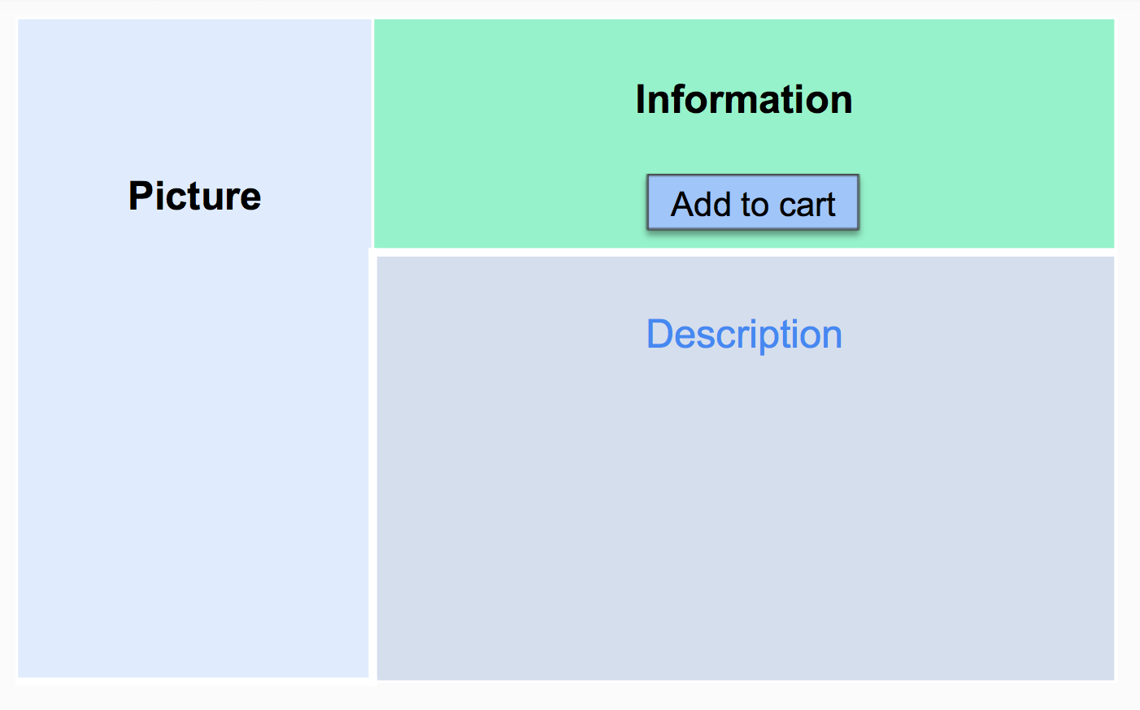

Description:

* Left: It used to show the pictures of the product;
* Top of right: It shows the detail information of product including title, category, price, popularity etc. And this area include the button of “Add to Cart”, when click this button, it will add the product to your shopping cart.
* Bottom of right: This area shows the description of the product.

Shopping cart page: From the link in the navigation bar, you can enter this page, and this page record the list of a buyer selected products, and give the total price, also you can finish your payment here.

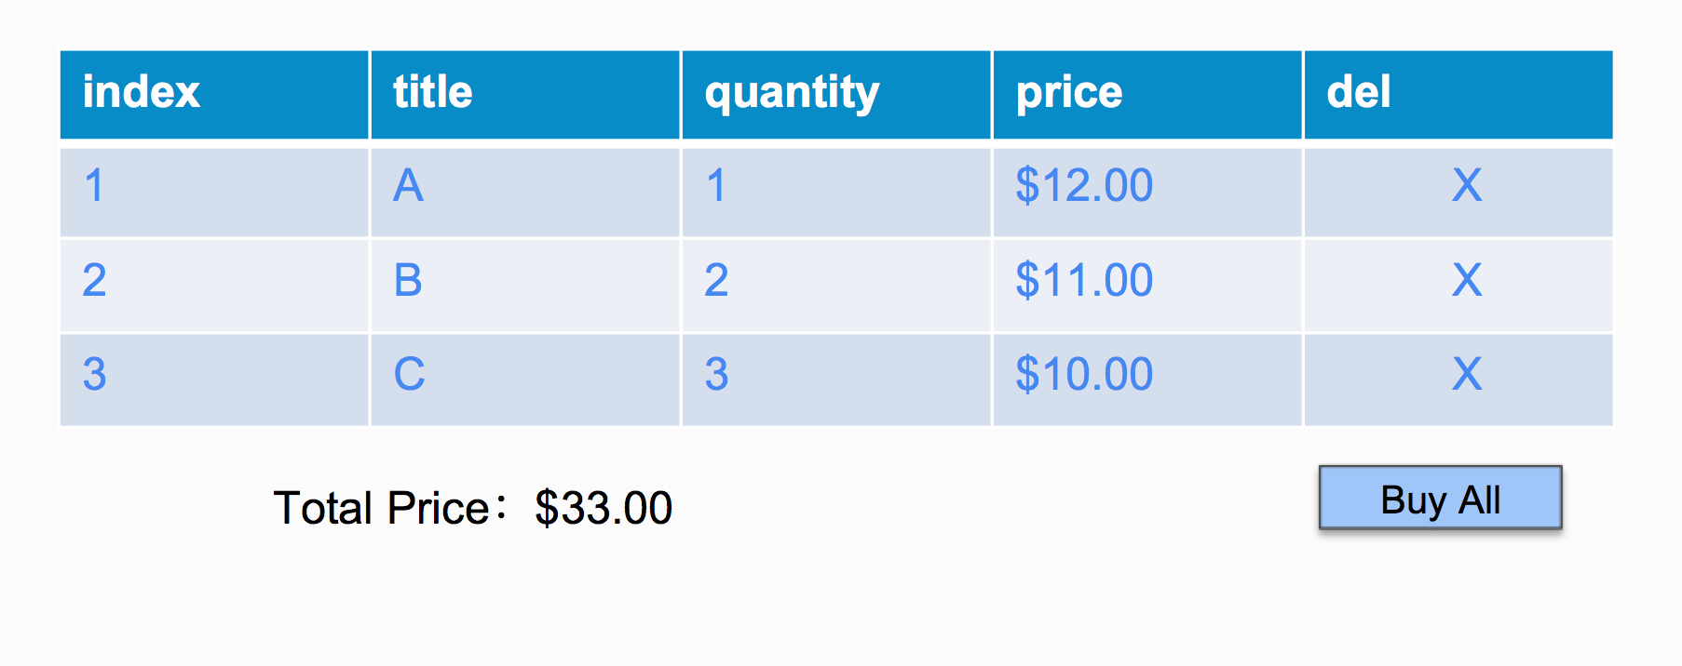

Description:

* Table area: Table area include the column of index, title, quantity, price, del, and about the del which can delete a product from the shopping cart; The quantity can be changed in this table.
* Total Price: It use to show the total price of the products.
* Buy All: It is a button of payment
* **A short explanation about where and how JavaScript/JQuery/Ajax and CSS have been used on the site**